Nueces River Authority Applauds EPA Decision to help disadvantaged communities apply for grants

U.S. Senate testimony by NRA’s John Byrum bears fruit

For immediate release February 29, 2024
For information contact
John Byrum 830-278-6810

Uvalde - The Environmental Protection Agency will expand access to $50 billion in the Bi-Partisan Infrastructure Act by assisting small, disadvantaged communities in seeking funding to improve drinking water, wastewater, and stormwater services.

According to EPA disadvantaged and underserved communities struggle to access federal funding because they lack the money to do the assessments required to apply for grants. To try to help, the EPA will offer engineering, planning and capacity building through its WaterTA program.

Nueces River Authority (NRA) Executive Director John Byrum is gratified to see the changes after providing Senate Committee testimony last November, stating that “rural, small and disadvantaged communities account for 77% of all water systems in the U.S. but are denied access to water funds because the process of applying, including providing a preliminary engineering report, exceeds a small community’s ability to pay for that process.”

Byrum also met with White House Office of Intergovernmental Affairs and recently attended the National Association of Counties legislative conference to explore expanding infrastructure funds to populations too small to have fair access to Texas Water Development Board’s grants and loans.

Nueces River Authority, 539 South Highway 83, Uvalde, Texas 78801

“The NRA is engaged and highly focused with assisting small and rural utilities as they struggle to meet the needs of their customers and the requirements of the federal and state regulations,” Byrum said.

“Research finds that small water systems serving 3,300 people or less, have higher rates of noncompliance under the Clean Water Act than larger systems. In addition, because small systems generally lack economies of scale, their customers face a particularly heavy financial burden to meet needs for clean water investments.”
Of the 1,210 cities in Texas, 834 or 68.9% have a population of less than 5,000. There is simply not enough money allocated in Texas for rural and small cities to meet these needs according to Byrum.
“In the Nueces River Basin almost all small cities have a median household income that is well below the national and state levels,” Byrum said. “In most cases, they are not able to compete for loan dollars.

An example of how the system is flawed is evident in a recent application for funds for the Duval County, Texas - Reclamation and Conservation District.” That district serves the communities of Realitos and Concepcion with a total combined population of 360 people. The median household income is only 44.4% of the average for the State of Texas.

“The water system serving these communities has been cited since 2015 for grossly exceeding the maximum containment level for arsenic in every sample taken,” Byrum told the Senate. “Their request for $1,665,000 to improve the arsenic removal to the water supply was not accepted due to the application not containing a preliminary engineering report.”

“They had a study detailing the levels of arsenic in the source water and drinking water, and how they proposed to improve the treatment to comply with the maximum contaminate limit, however today, these people are still drinking and bathing in water that is much higher than the maximum limit for arsenic,” Byrum said.

EPA’s announced move may reduce the administrative burdens for water grant access in Texas.

The Duval County District is just one example of the type of utilities in the Nueces River Basin, where the State Revolving Programs, even with set-a-sides for small systems, are not working according to Byrum who also asked
the Senate Environment and Public Works Committee for a greater percentage of the total money become available for small systems.

“Even with the Inflation Reduction Act (IRA), the amount of federal outlays for environmental and water spending only matches the lowest year of the Reagan Administration, which was 1.3% of total federal outlays,” said Byrum.

“When it comes to water, the IRA’s water funding is below the JFK, LBJ, Nixon, Ford, Carter, George H.W. Bush and Clinton Administrations overall water outlays,” said Byrum who added, “We must increase the level of spending and address the infrastructure issues in our water and wastewater systems.”
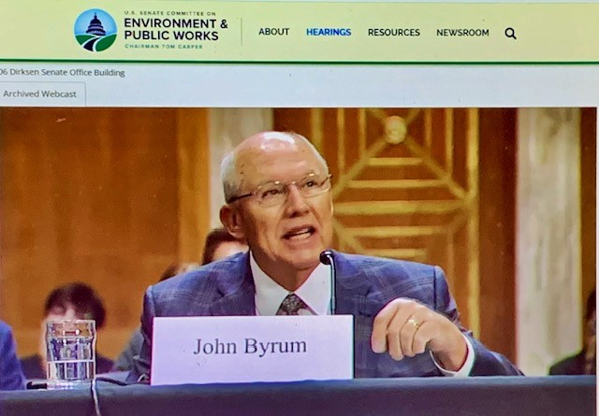
Nueces River Authority Executive Director John Byrum testifying to the Senate Environment and Public Works Committee November 8, 2023

